**Objective 10**

**Q1. Make a CSV file containing Income and Expense of a  company for 12 months i.e. Jan  to Dec  .Using pandas library and CSV concept make a simple system to Plot and show the following…**

Ø  **Last three months and first Three months Income and expense record with BAR GRAPH**

Ø  **Maximum income containing Month**

Ø  **Plot a Pie graph for Income also set index as Month**

Ø  **Minimum Income containing month With PIE Graph**

Ø  **Total cash in hand after dec., 2019. With graph.**

Ø  **Loss and profit month wise.**

Answer:

Code:

import pandas as pd

import matplotlib.pyplot as plt

# reading csv file and making a dataframe from csv files

df=pd.read_csv("objective 10.csv")

#data.csv file is present in your cwd , having columns Marks 1, Marks2, Name

#first three months

print("menu driven program :\n 1.press 1 to print first 3 months. \n2.press 2 to print last three months \n3.Maximum income containing Month \n4.Plot a Pie graph for Income also set index as Month \n5.Minimum Income containing month With PIE Graph \n6.Total cash in hand after dec., 2019. With graph. \n7.Loss and profit month wise. ")

print("Enter your choice :")

a=int(input())

if(a==1):

df1=df.head(3)

df1.plot.bar()

plt.show()

if(a==2):

df2=df.tail(3)

df2.plot.bar()

plt.show()

if(a==3):

ind=df[['Income']].idxmax()

df2=df.loc[ind]

print("maximum Income :",df['Income'].max(),"RS at month :",df2['month'])

#print("maximum amount of Income:",maximum,"RS")

if(a==4):

# creating dataframe

#df2=pd.DataFrame(df['Income'])

df2=df.set_index('month')

df3=df2['Income']

print(df3)

df3.plot.pie(subplots=True)

plt.show()

##

if(a==5):

ind=df[['Income']].idxmin()

df2=df.loc[ind]

print("mnimum Income :",df['Income'].min(),"RS at month :",df2['month'])

if(a==6):

total=df['Income'].sum()

print("total Income :",total)

if(a==7):

df1=df['month']

df2=pd.DataFrame(columns=['Profit OR LOSS'])

df2['Profit OR LOSS']= df['Income']-df['Expense']

frames=[df1,df2]

res=pd.concat(frames,axis=1)

print(res)

res.plot()

plt.show()

output:

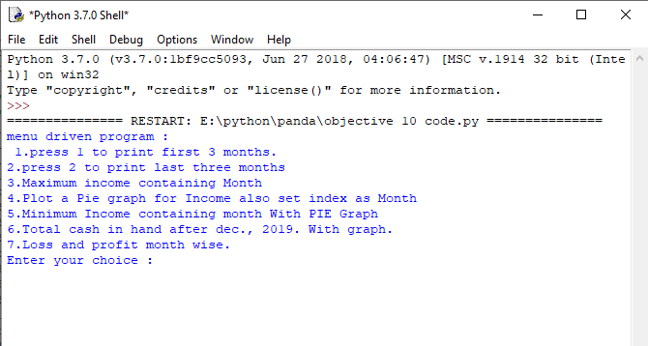

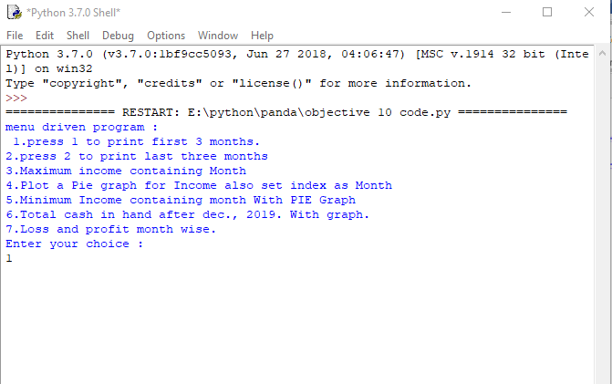

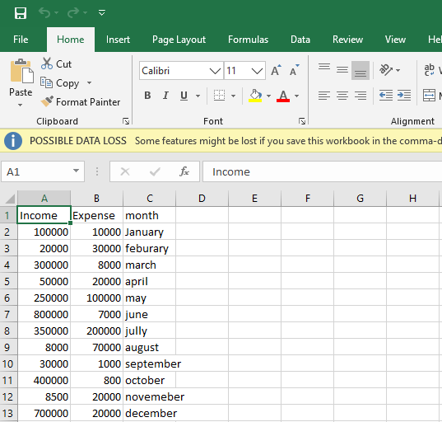

1. Bar graph

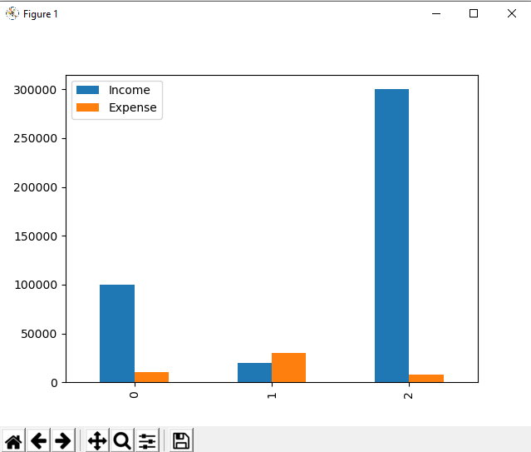

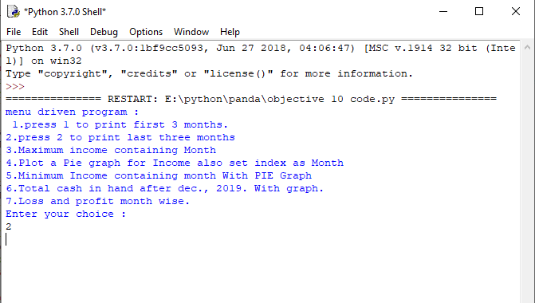

1. Bar Graph

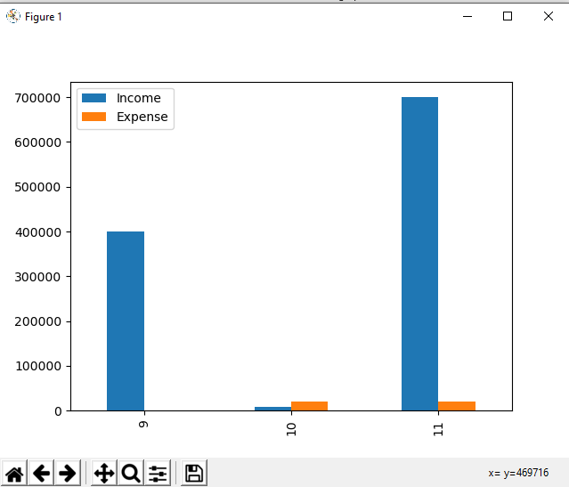

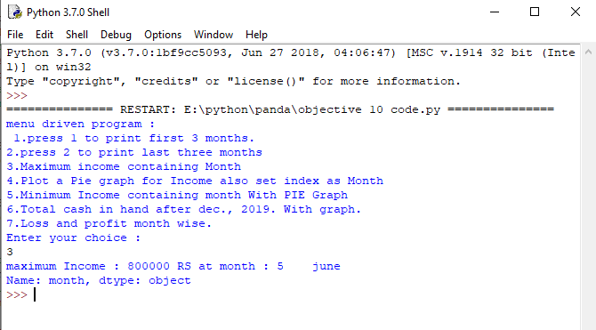

4 pie graph

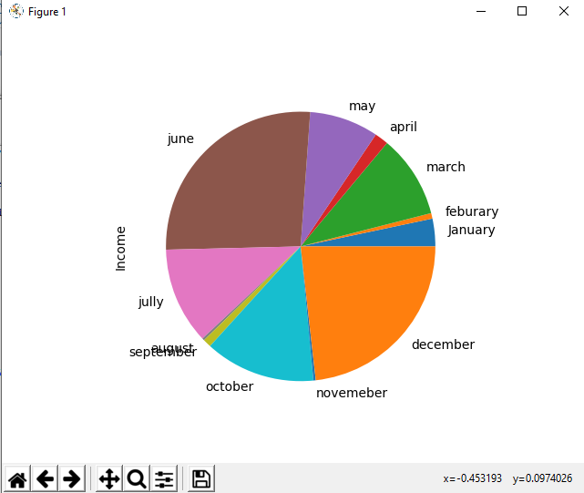

5

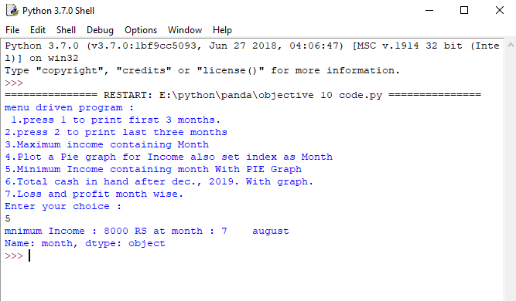

6.

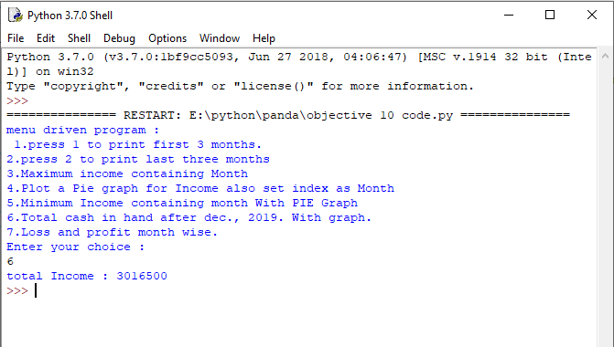

7.

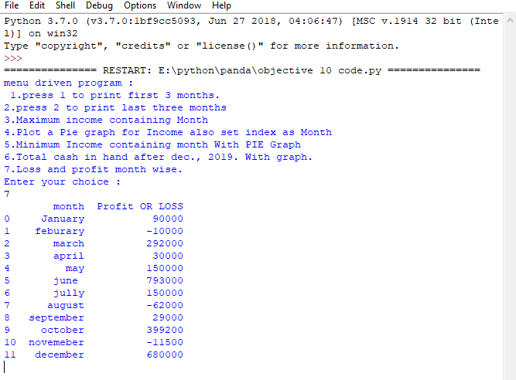

Line graph of 7:

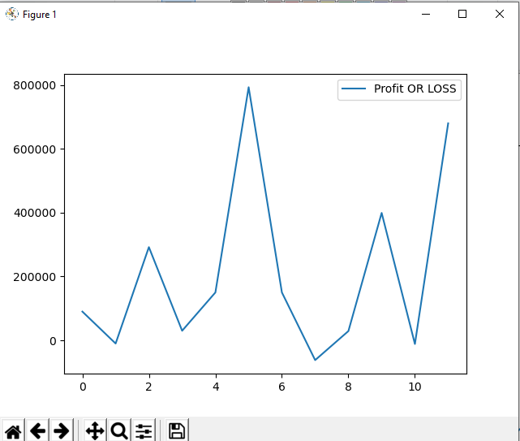

**Q2: From The blow link kindly download the csv file.**[**https://pynative.com/wpcontent/uploads/2019/01/Automobile_data.csv**](https://pynative.com/wpcontent/uploads/2019/01/Automobile_data.csv)**then apply the following pandas operations  
1. From given data set print first and last five rows  
2. Find the most expensive car company name  
3. Print All Toyota Cars details  
4. Find each company’s Highest price car  
5. Concatenate the Data of two Data  frames    
6. Merge the data of  two DATA Frames.**

Answer:

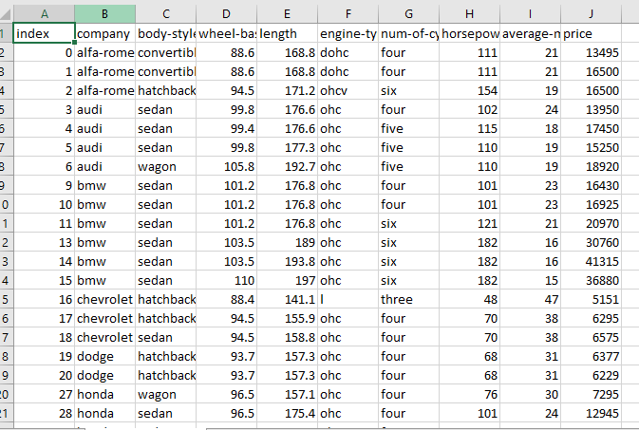

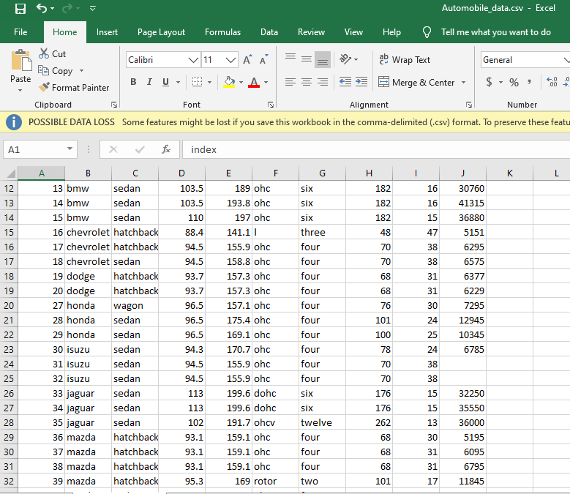

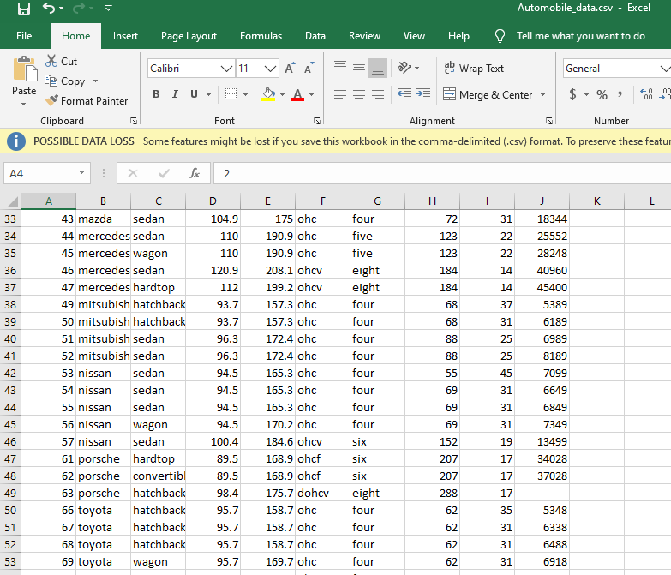

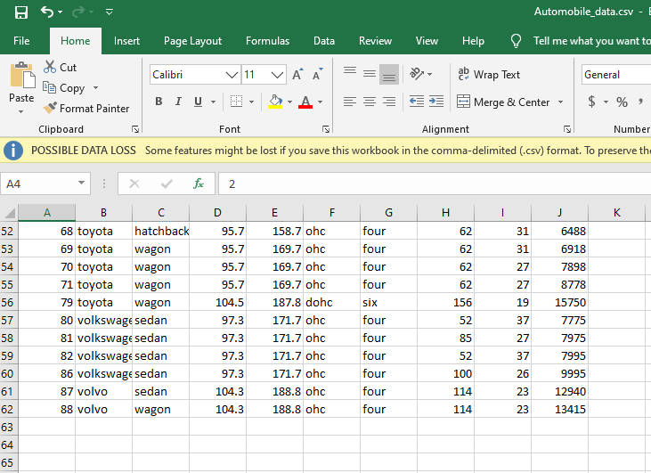

**1: From given data set print first and last five rows:**

import pandas as pd

df = pd.read_csv("Automobile_data.csv")

df.head(5)

output

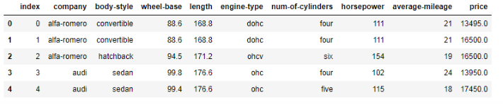

import pandas as pd

df = pd.read_csv("Automobile_data.csv")

df.tail(5)

output

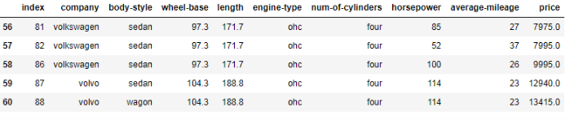

### 2: Clean data and update the CSV file.

### df = pd.read_csv("Automobile_data.csv", na_values={

### 'price':["?","n.a"],

### 'stroke':["?","n.a"],

### 'horsepower':["?","n.a"],

### 'peak-rpm':["?","n.a"],

### 'average-mileage':["?","n.a"]})

### print (df)

### 3: Find the most expensive car company name?

### import pandas as pd

### df = pd.read_csv("Automobile_data.csv")

### df = df [['company','price']][df.price==df['price'].max()]

### df

### output

### 

### 4: Print All Toyota Cars details

### import pandas as pd

### df = pd.read_csv("D:\\Python\\Articles\\pandas\\automobile-dataset\\Automobile_data.csv")

### car_Manufacturers = df.groupby('company')

### toyotaDf = car_Manufacturers.get_group('toyota')

### toyotaDf

### output:

### 

### 6: Find each company’s Higesht price car

### import pandas as pd

### df = pd.read_csv("D:\\Python\\Articles\\pandas\\automobile-dataset\\Automobile_data.csv")

### car_Manufacturers = df.groupby('company')

### priceDf = car_Manufacturers['company','price'].max()

### priced

### output:

### 